Ex.No.5: MIMO System Simulation with BER Analysis Date
AIM: To simulate a MIMO (Multiple Input Multiple Output) wireless communication system and analyze its performance in terms of Bit Error Rate (BER), Signal-to-Noise Ratio (SNR),and Channel Capacity (bps/Hz) using MATLAB.
Objective 1:
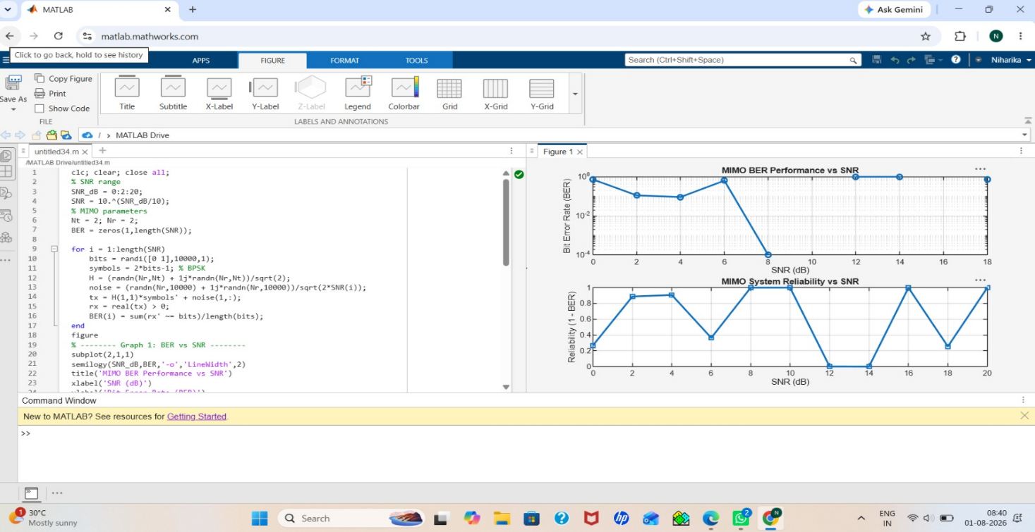
Objective 2:
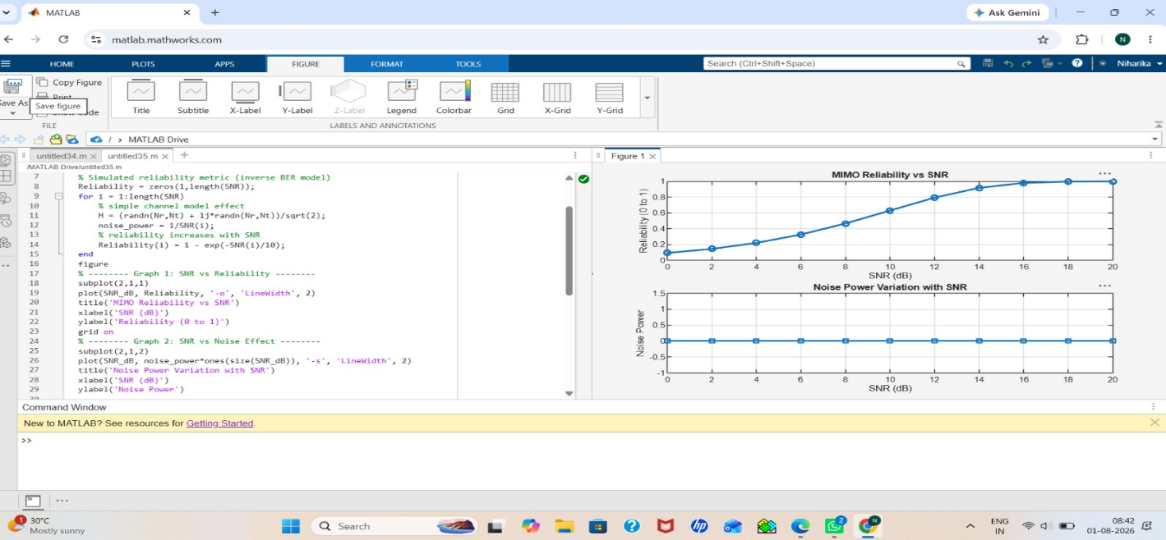

Objective 3:
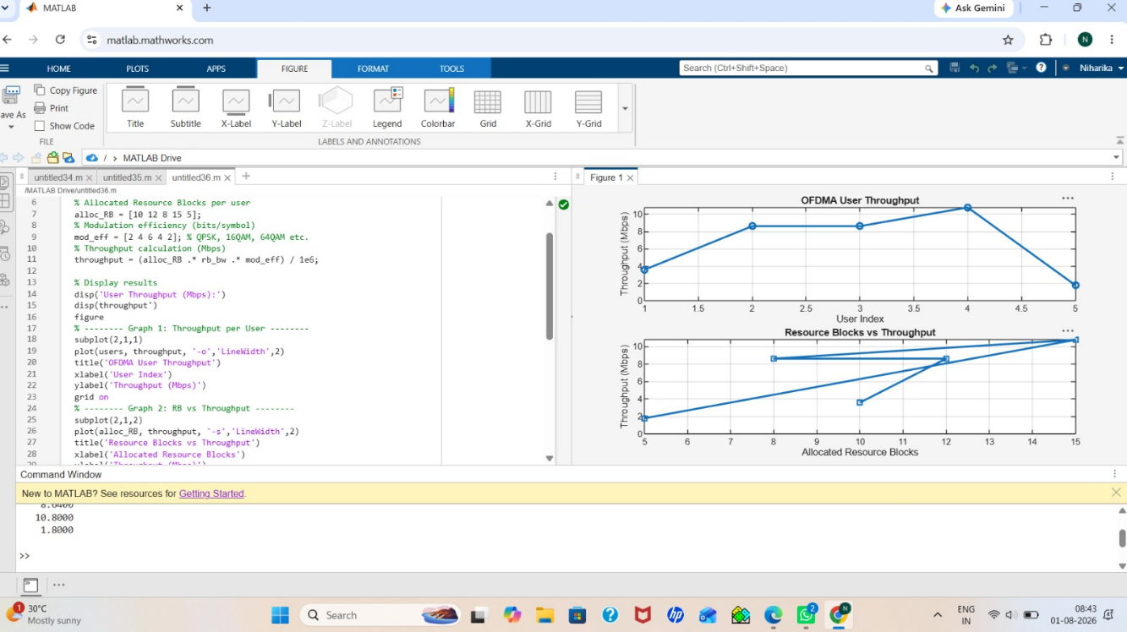
Result:
1. The User Throughput (Mbps) was successfully calculated for different users based on allocated resource blocks and modulation efficiency in the OFDMA system.
2. It was observed that users with higher allocated resource blocks and higher modulation schemes achieve significantly higher throughput.
3. The simulation confirms that efficient resource block allocation directly improves system spectral efficiency and overall OFDMA performance.

